NEMS (Noise Exposure Management System)
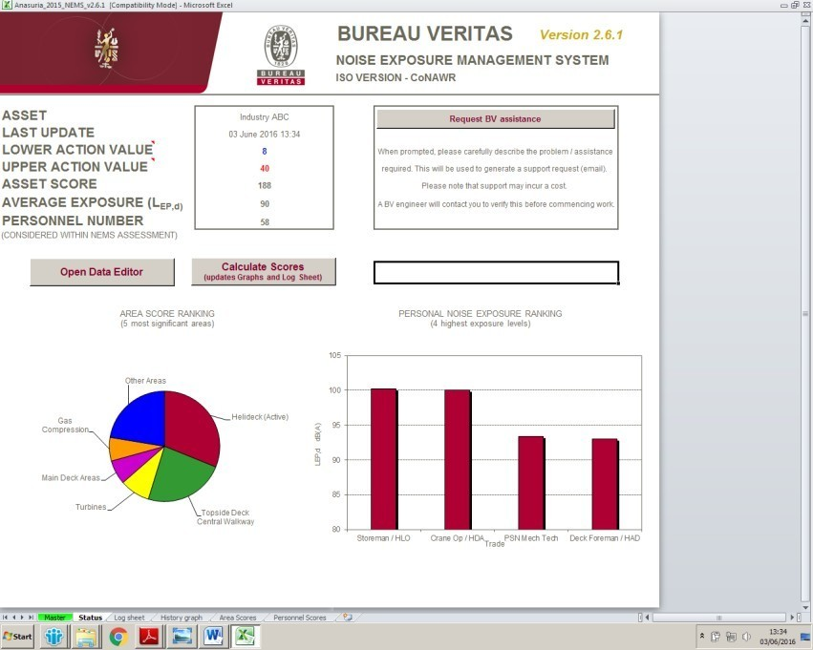

Tagline: A comprehensive noise management system to facilitate compliance with CoNAWR (Control of Noise at Work Regulations).
Link Text: Helping our client managing noise exposure and achieve compliance.

General Text
Effective noise management is critical to reducing the risks of Noise Induced Hearing Loss associated with long-term exposure to noise and to ensure compliance with the Control of Noise at Work Regulations. Noise management is particularly important for the offshore industry where there is major equipment operating in a confined environment.
What is NEMS?
Bureau Veritas’ NEMS (Noise Exposure Management System) has been specifically developed to simplify the assessment process and to form the cornerstone of comprehensive noise management. NEMS is developed and offered exclusively by Bureau Veritas. It is a comprehensive management system used widely across the oil and gas industry both onshore and offshore. It provides a systematic approach to noise management and provides consistency, easy and effective comparability in determining noise risk across the industry.
The system also provides recording facilities for the assessment of ongoing compliance and illustrates commitment to reducing noise exposure. The results of the assessment can be used to quantify Key Performance Indicators (KPIs) in relation to noise exposure risk.
NEMS Benefits
NEMS provides a powerful tool for managing risk and enables the following:
- Calculation of personnel’s noise exposure levels
- Identification of trades requiring health surveillance / noise awareness training
- Identification of areas / tasks making the greatest contribution to noise exposure
- Targeted work practice reviews to identify organisational controls to reduce personnel exposures
- Targeted noise control studies to identify technical / engineering control measures to reduce exposures As Low As Reasonably Practicable
- Determination of the effectiveness of noise control measures to ensure cost effective risk reduction
- Provision of indicators and recording facilities for assessment of ongoing compliance
- Assessment of the effectiveness of hearing protection
- Assistance in the formulation of a noise action plan
Furthermore, noise management auditing, undertaken as part of the NEMS survey, identifies the key actions required to achieve compliance with the Regulations. These actions are incorporated into an embedded noise action plan to ensure compliance and effective noise management

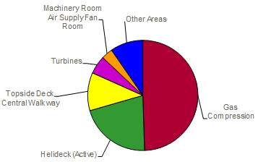
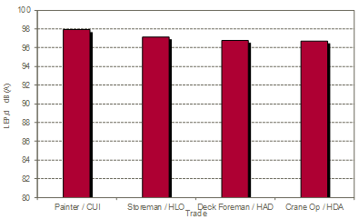
Areas Ranking Scores:
Determines the highest contributing areas to people’s noise exposure. By introducing noise control in these areas, it will yield the biggest benefits in terms of noise exposure of work force.
Personnel Noise Exposure:
Predicts personnel noise exposure based on measured noise levels and work pattern information. Accurately predicting personnel’s exposure means we know what noise category they fall under and therefore the appropriate legislation that applies.

Why Choose Bureau Veritas
The Acoustics and Vibration team a specialist division of Bureau Veritas and has been supplying noise management services to the Oil & Gas sector across both UKCS waters and worldwide.
We pride ourselves in our customer focus. While delivering services that keep up the tradition of impartiality that has made Bureau Veritas a world leader, we aim to help and assist our clients to achieve best practice and compliance with the legislation.

Pipework Vibration
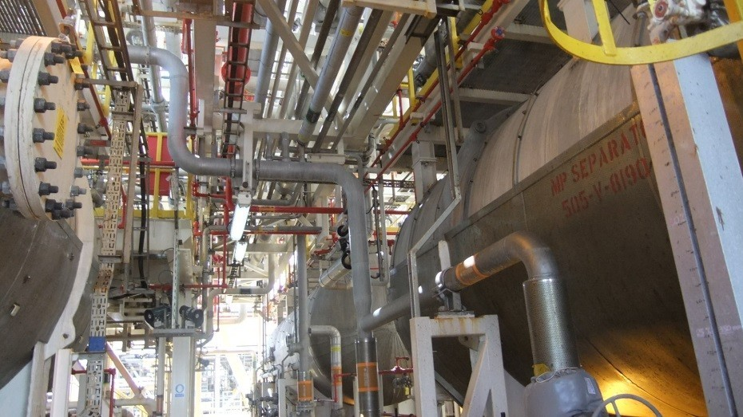
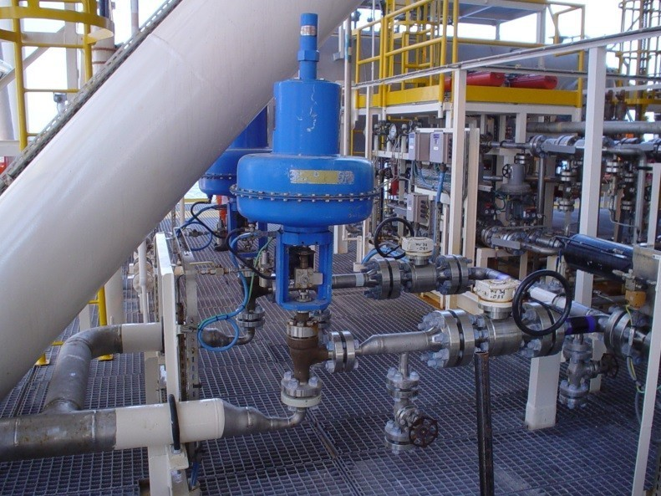

Tagline: Providing bespoke solutions to help prevent, assess and manage risks associated with vibration induced fatigue failures.
Link Text: Delivering specialist Asset Integrity Management Services

General Text
In some situations a detailed investigation and assessment is required to determine why a piping failure has occurred and what can be done to ensure that the problem is prevented from re-occurring.
An investigation to avoid a piping failure can help save money and avoid down-time. Bureau Veritas can provide a tailored measurement survey campaign to understand the source of the problem. Too often in the industry a generic stiffening of the pipework via additional supports and/or clamps is seen as the way ahead. But this is not always carried out with vibration in mind and may not be the only (or best) solution available.
Our dedicated response
Bureau Veritas were involved in the development and update of the Energy Institute “Guidelines for the Avoidance of Fatigue Induced Failure in Process Pipework” (2008) and therefore have significant experience in carrying out surveys based on this and other risk based assessment techniques.
As part of this commitment Bureau Veritas has worked closely with the oil and gas industry and the regulatory authorities to develop a risk assessment methodology to identify areas at risk from vibration induced failures: the Process Screening Integrity (PSI) technique.
The Process Screening Integrity (PSI) predictive technique is suitable for both new facilities (even at FEED stages) as well as those already in production. For new facilities, PSI can identify pipework at risk from vibration fatigue in the design phase, so appropriate modifications can be made before the facility is put in operation. For operational facilities, the results of a formal study, supported by field measurements, can show the way to reduce or eliminate the potential failures due to fatigue. The PSI screening method is also a good starting point to identify high risk areas and where to focus subsequent measurement campaigns and mitigation programs.
Our services
Bureau Veritas can perform different types of assessments whose size and scope depend on our clients’ requests and needs. These include:
- Full scale or area focused Vibration Risk Assessments (VRAs) to evaluate and rank by risk the possible integrity threats within a plant/installation. All pipework is assessed via the use of a mixed technique including PSI pre-screening, vibration and dynamic stress measurements and visual assessments, etc.
- Collected vibration data are compared against accepted criteria and ranked accordingly to the likelihood of failure (i.e. Concern and Danger) as per the EI Guidelines. Where problems are encountered, further investigation is carried out.
- Dynamic strain measurements (on both the main line and small bore connections); particularly useful to identify Small Bore Connections (SBCs) at risk of fatigue failure.
- Multi-channel ODS (Operational Deflection Shape) and modal analysis of the pipework or structure.
- When it comes to introducing supports and clamps to the pipework, Bureau Veritas can be part of the design and review stages to ensure that these measures are effective against vibration threats and not merely stiffening the piping.
- PSI (The Process Screening Integrity) pre-screening technique: a desk based assessment useful for both existing and FEED stage plants to identify vibration mechanisms not identifiable via the traditional measurements campaign, such as Acoustic Induced Vibration (AIV), Flow Induced Vibration (FIV) and Flow Induced Pulsation (FLIP). It is useful to combine this pre-screening technique with future on site surveys to help cut down site time and identify potential vibration root causes.
- Pipework vibration awareness training to site personnel to help them understand the basics of pipework vibration and recognise good/bad configurations of supports. The experience Bureau Veritas has gained in both offshore and onshore installations in the UK and worldwide is transferred across to site personnel for a proactive approach to managing pipework vibration issues with the help of those people that look after the installation.
- FEA Simulation for structures affected by vibration. Recent projects include the FE analysis of skids supporting gas compressors and gas turbines and the introduction of additional stiffening to the skids.
Why Choose Bureau Veritas?
The Acoustics and Vibration team a specialist division of Bureau Veritas and has been supplying noise management services to the Oil & Gas sector across both UKCS waters and worldwide.
We pride ourselves in our customer focus. All our services are tailored to our clients’ needs and ad hoc solutions developed to meet their requirements. While delivering services that keep up the tradition of impartiality that has made Bureau Veritas a world leader, we aim to help and assist our clients to achieve best practice and reduce downtime and/or safety issues.

Occupational Noise

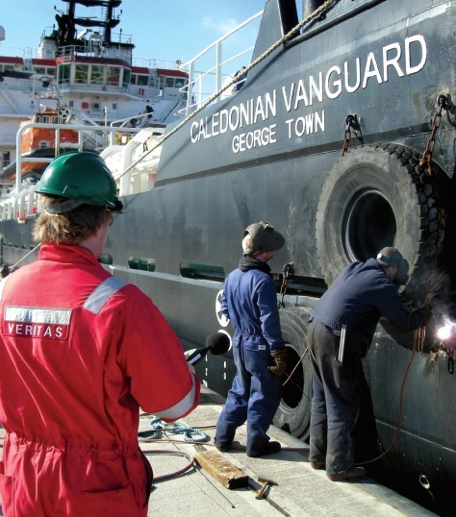

Tagline: Our team of acousticians have extensive experience to help you manage all your occupational noise requirements.
Link Text: Noise risk assessments, production of noise management plans, auditing and more.
General Text
It is estimated that about one million people in the UK are working in conditions that may damage their hearing unless precautions are taken (source: National Society for Clean Air and Environment Protection, NSCA). Prolonged exposure to high levels of noise can lead to stress, fatigue or even deafness. Employers have a duty of care to protect employees who may be at risk of exposure to noise at work.
If your company is involved in manufacturing, fabrication or engineering, you know that it is essential to manage carefully and continuously your quality, health & safety and environmental issues throughout your industrial process.
The Control of Noise at Work Regulations (CoNAWR)
The Control of Noise at Work Regulations place a duty of care on employers to protect all employees who may be at risk of exposure to noise and vibration. The Acoustics and Vibration team has a long history of providing services in this area both onshore and offshore. Whether an industrial plant, an offshore installation or a shipping or fishing vessel (under the Merchant Shipping and Fishing Vessels Control of Noise at Work Regulations), we can help manage noise and achieve compliance.
Our Services
When it comes to occupational noise we offer a broad range of services. These include:
- Assessment of employee exposure to noise
- Provision of management plans, policies and procedures to manage the risk and enable compliance with the regulations and HSE requirements
- Noise management audits
- Work place risk assessments
- Workplace noise mapping
- Noise design and control studies
- Audiometry programme audits and assessments
- Noise dosimetry studies
- Noise awareness and Noise Competent Person (NCP) training of local operators in assessing noise and vibration
- PA and alarm assessments, design and verification (SOLAS)
- Expert witness
The benefits:
- Demonstration of compliance with the regulations
- Identification of high risk activities to allow jobs to be re-planned
- Significant time and cost savings through identification of noise control options providing the greatest benefits
These services can be combined and carried out at the same time as part of a multi-disciplinary survey including, among others, occupational hygiene and occupational vibration. Please see our dedicated page for occupational vibration here.
NEMS (Noise Exposure Management System)
In some cases it can be beneficial to manage site noise exposure via the use of NEMS (Noise Exposure Management System). Developed and offered exclusively by the Acoustics and Vibration Group of Bureau Veritas, NEMS is a comprehensive management system used widely across the offshore industry to further demonstrate compliance with the Control of Noise at Work Regulations.
The system calculates noise exposure levels for the workforce, identifies areas or tasks which make the greatest contributions to noise exposures on site, and provides risk indicators and recording facilities for assessment of ongoing compliance. The system can also be used to model the potential effectiveness of different noise control measures to ensure cost-effective risk reduction. To learn more about NEMS, check our dedicated page here.
PA and Alarm Systems Assessments
We can perform tests on Public Address and Alarm systems including direct measurement of the acoustic performance of the system for audibility and intelligibility, typically comprising an alarm sound level survey and quantitative speech intelligibility tests. Surveys can be carried out either for verification purposes (to provide compliance with the written scheme of examination) or to help improve system performance.
This type of assessment is suitable for offshore installation and vessels and can be carried out against industry compliance criteria or specific operators’ requirements.
Why Choose Bureau Veritas?
The Acoustics and Vibration team is a specialist division of Bureau Veritas and has been supplying noise and vibration management services to clients worldwide.
We pride ourselves in our customer focus and can provide a cost-effective solution to help you meet your regulatory requirements. While delivering services that keep up the tradition of impartiality that has made Bureau Veritas a world leader, we aim to help and assist our clients to achieve best practice and reduce downtime and/or safety issues.
Bureau Veritas Acoustics and Vibration operates across regional offices located in Aberdeen, Glasgow, London, and Manchester.
Environmental Noise

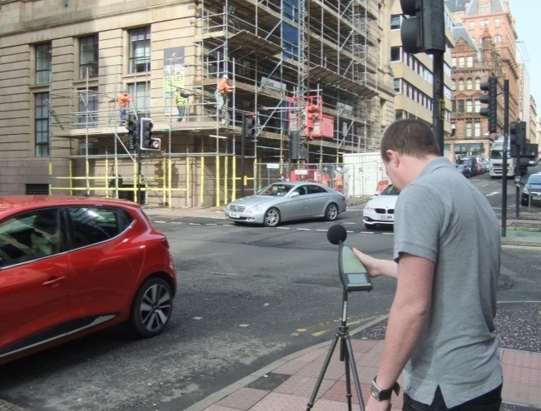

Tagline: Bureau Veritas conduct environmental noise impact assessments to comply with local or national legislation.
Link Text: Supporting planning or permit applications for new developments.
Our Services
Almost all industrial operations have the potential to generate noise and vibration which, in turn, have the capacity to cause nuisance at nearby receptors. Regulatory authorities normally require noise and vibration assessments to be undertaken as part of planning or licence applications for new industrial developments. In addition, operators often also must satisfy Integrated Pollution Prevention and Control (IPPC) regulations which relate to how the environmental impacts of the site are managed.
Planning for Noise
The National Planning Policy Framework (NPPF) has created opportunities and challenges for planners and planning consultants.
Local or national regulatory authorities normally require a noise assessment to be undertaken as part of planning or licence permit applications for new industrial developments which have the potential to produce noise and/or vibration that could affect existing residential or other noise sensitive areas. Likewise, the effects of existing noise and/or vibration on proposed sensitive development need to be assessed at an early stage to allow sustainable controls to be incorporated in their design.
Environmental Noise & Vibration and IPPC
The Acoustics and Vibration team can assist operators with environmental noise and vibration management and permit applications with the following range of services:
- Ambient noise and vibration monitoring to BS, EN and ISO standards
- Noise and vibration assessment to accompany a planning or licence permit application for a new/modified industrial sites
- Development of noise management plans and environmental noise management systems
- Prediction of noise propagation and impacts using complex 3D modelling software packages
- Provision of engineering design advice to ensure that the noise and vibration emissions from a proposed new or modified/existing plant complies with appropriate limits
- Prediction and monitoring of construction noise and vibration
- Prediction and measurement of road, rail and aircraft noise
- Acoustic design advice and specification, including façade and room-space analysis
- Construction Management Plans, and COPA Section 61 Agreements
- Full technical support following the EIA process from masterplan development, through the detailed impact assessment and support at Public Inquiries or Hearings as an Expert Witness
- Policy advice and support to government and other regulatory bodies, including detailed review of robustness of noise and vibration assessments presented with planning applications
- Liaison and negotiation with regulatory authorities regarding noise limits and planning or environmental licence permit conditions
Other related services offered include prediction, assessment and monitoring of construction noise/vibration, occupational noise and vibration risk assessments.
These assessments can also be combined and carried out at the same time as other services carried out by Bureau Veritas, including air quality assessments, thus reducing costs for our clients.
Why Choose Bureau Veritas?
The services of Bureau Veritas’ Acoustics and Vibration team are deployed to a wide range of clients and sectors, including numerous private land developers and planning consultancies; major blue chip organisations; the aviation industry; offshore operators and government departments. The sectors in which we have significant experience in conducting environmental assessments include land and property, manufacturing and the built environment; power generation and transmission, demolition and construction; transport and infrastructure including rail, road, aviation, and marine; water and gas distribution; waste, mining and quarrying industries; and renewable energy sector.
Our service range covers the impacts of noise and vibration in the environment, on people as well as on structures and machinery.

Building and Architectural Acoustics


Tagline: We provide advice and measurement for building projects which require a consideration of noise and vibration issues.
Link Text: Acoustic design advice and measurement.
General Text
The acoustic performance of many buildings is critical to their overall success. Our Acoustics and Vibration team offer acoustic consultancy services to those involved in the design and management of buildings with the aim of achieving appropriate acoustic conditions both inside and outside the finished project.
What are the Key Services?
Our team work on a variety of building types including education, health, leisure, commercial, residential and industrial buildings.
Our acoustic consultancy advice includes the following:
- External noise ingress from environmental sources such as road/rail traffic or aircraft.
- Sound insulation between internal areas through walls, floors, doors, etc.
- Control of impact sound, e.g. footfall on floors
- Internal acoustics and control of reverberation time
- Rain noise assessment and mitigation
- Vibration isolation
- Plant noise assessment
As well as advice during design, we can also offer onsite inspection to assess issues such as workmanship or material selection, and testing on completion. We are members of the Association of Noise Consultants and are registered to undertake sound insulation testing under their Pre Completion Testing Registration Scheme to assess compliance against Approved Document E to the Building Regulations.
We also provide advice on acoustic issues in existing buildings and offer guidance on remedial measures to enhance their performance.
Other related services offered by Acoustics and Vibration include provision of noise assessments for planning purposes, verification of the acoustic design/specification of voice evacuation alarm and public address systems.
Why Choose Bureau Veritas?
Acoustics and Vibration is a specialist division of Bureau Veritas, a world leader in independent verification and advice.
We pride ourselves on our customer focus and pragmatic approach. Our services are tailored to our clients’ needs and ad hoc solutions developed to meet their requirements. While delivering services that keep up the tradition of impartiality that has made Bureau Veritas a world leader, we aim to assist our clients to achieve best practice and compliance with the legislation.

Hand-Arm and Whole-Body Vibration
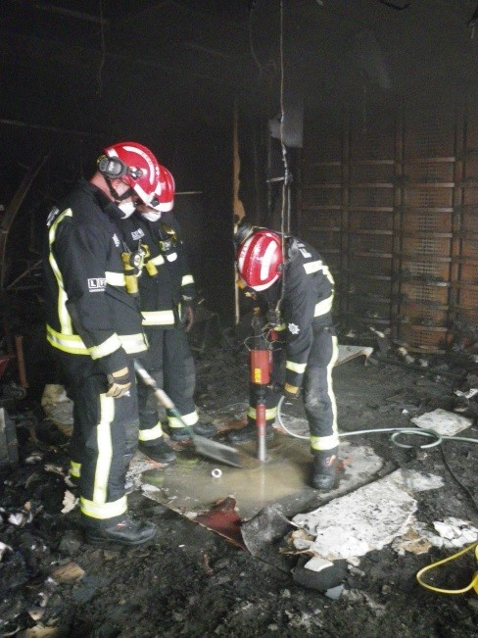


Tagline: Bureau Veritas delivers vibration risk assessments, production of management plans, audits, etc.
Link Text: Helping you comply with the Control of Vibration at Work Regulations

Control of Noise at Vibration Regulations 2005 (CoVAWR)
According to the Health and Safety Executive (HSE Statistics: Causes and Kind of Disease – Hand-Arm Vibration Syndrome), Hand-Arm Vibration Syndrome (HAVS) has become the most commonly reported disease under RIDDOR (Reporting of Injuries, Diseases & Dangerous Occurrences Regulations). Over exposure of hands to high levels of vibration can lead to permanent disability of equipment operators.
With the introduction of the Control of Vibration at Work Regulations (the UK implementation of the EU Physical Agents Directive) there is now a clear and direct duty on employers to assess and manage the vibration risks associated with the use of vibrating tools and equipment. This also extends to vibration risks associated with whole body vibration, typically experienced when seated or standing in areas where vibration is experienced. The operation of high vibration tools, and sitting or standing in high vibration areas for extended periods, can lead to possible injury and, in particular, damage to blood circulation.
Failure to comply with these Regulations could lead to legal action (liability for compensation, and prosecution under the Health and Safety at Work Act 1974). Addressing workplace noise and vibration issues could also improve productivity, through a better working environment, and more efficient plant/operations.
Whether an industrial plant, an offshore installation or a shipping or fishing vessel (under the Merchant Shipping and Fishing Vessels Control of Vibration at Work Regulations), we can help manage occupational vibration and achieve compliance.
What are the Key Services?
The Acoustics and Vibration Group, a specialist division of Bureau Veritas, offers services for identifying and managing both hand-arm and whole-body vibration in the workplace and can provide cost-effective solutions to help employers meet the regulatory requirements. Our services include:
- Assessment of employee exposure to Hand-Arm Vibration (HAV) and Whole-Body Vibration (WBV)
- Compilation of hand-held equipment datasheets and associated time to achieve the regulatory exposure action values as defined in CoVAWR
- Provision of vibration management plans to enable compliance with the regulations and HSE requirements
- Workplace risk assessments
- Identification of tools or processes likely to induce HAVS
- Measures to reduce occupational vibration
- Measures to reduce occupational vibration
- Training of local operators in assessing vibration. Discover our dedicated training page here.
VEMS (Vibration Exposure Management System)
Bureau Veritas have developed VEMS (Vibration Exposure Management System) to simplify the assessment process. It allows a user friendly management system of vibration exposure allowing employers to monitor the personnel exposure over time and avoid exposure in excess of the regulatory action values.
The results of the assessment can be used to quantify Key Performance Indicators (KPIs) in relation to vibration exposure risk.
VEMS provides a powerful tool for managing risk and enables the following:
- Calculation of personnel’s vibration exposure levels
- Provision of indicators and recording facilities for assessment of ongoing compliance
Why Choose Bureau Veritas?
The Acoustics and Vibration team a specialist division of Bureau Veritas and has been supplying noise and vibration management services to the Oil & Gas sector across both UKCS waters and worldwide.
We pride ourselves in our customer focus and can provide a cost-effective solution to help you meet your regulatory requirements. While delivering services that keep up the tradition of impartiality that has made Bureau Veritas a world leader, we aim to help and assist our clients to achieve best practice and reduce downtime and/or safety issues.
Bureau Veritas Acoustics and Vibration operates across regional offices located in Aberdeen, Glasgow, London, and Manchester.

Noise and Vibration Training

Tagline: Bureau Veritas provide noise and vibration training as per the requirements outlined by the HSE.
Link Text: Noise Competent Person, NEMS and HAVS training and other courses.
Bureau Veritas offer a range of noise and vibration training courses run by experienced and current practitioners in the noise and vibration field.
Occupational noise and vibration training courses are usually run from our training centre in Glasgow. Where different arrangements are required this is possible with prior discussion.
A series of dates are available for open courses and additional dates can be arranged assuming that the minimum number of trainees can be met. To see our training courses diary and next available dates, please check our dedicated page here.
Pipework Vibration Awareness courses are usually held at the client’s premises and are aimed at integrity and maintenance engineers and tailored on the observations made on site.
Noise at Work Competency Training
The noise at work competency training course will last 3 days inclusive of both classroom time and a practical session at industrial facilities. The course will cover a range of topics starting with the fundamentals and basics of acoustics and sound through to the requirements and implementation of the 2005 Control of Noise at Work Regulations (CoNAWR). The modules taught include the following:
• The basics of sound;
• Mechanisms of hearing/ hearing loss and the ear;
• Definition of sound level;
• Decibel calculations;
• Noise exposure and its calculation;
• Noise measurement and sound level meters;
• The requirements of the Control of Noise at Work Regulations;
• Hearing protection.
• Practical operation of a dosemeter.
The course incorporates a ½ day practical session at industrial facilities with the use of a sound level meter and survey requirement. The measured noise levels will then be used to prepare a noise assessment, in line with the Control of Noise at Work Regulations.
An additional 1 day course can be added as a completion to the above training to gain competency in the use of Bureau Veritas’ Noise Exposure Management System (NEMS). This course includes:
- Introduction to NEMS
- Practical use of NEMS;
- Use of NEMS to determine overall effect on noise levels and exposure; and
- Use of Area Leq’s and dosimetry data with the NEMS system.
Bureau Veritas will supply course notes, copies of the CoNAWR and calculators.
HAVS Training
The HAVS training course will last 1 day and cover a range of topics covering practical HAVS management through to the requirements and implementation of the 2005 Control of Vibration at Work Regulations (CoVAWR). The course content will include:
- Introduction to Hand Arm Vibration Syndrome (HAVS);
- Hand arm vibration risks;
- Legislation relating to HAVS (including reference to the 2005 Control of Vibration at Work Regulations);
- Vibration theory and vibration levels;
- Vibration meters and their use;
- Vibration exposure;
- Management of HAVS:
Following the course it is expected that the delegates will be able to:
- Operate an on-site hand arm vibration management programme;
- Understand and, if necessary, measure hand arm vibration levels;
- Assess and plan jobs to control HAVS risks;
- Communicate information about HAVS risk and good practice to tool users.
Pipework Vibration Awareness Training
The Pipework Vibration Awareness Training courses are usually aimed at integrity and maintenance engineers working on site. This training is particularly useful for installations were vibration exacerbates existing issues due to aging but it also helps personnel not to turn a blind eye to potentially hazardous arrangements.
The course consists of a ½ day session aimed at developing a trained eye for possible pipework vibration induced hazards with particular attention to Small Bore Connections (SBCs). The course is usually carried out by a vibration engineer along with other site vibration services and as such is tailored to the specific site by collecting pictures and examples of both good and bad practice.
The course covers the following topics:
- Vibration as a failure mechanism
- Vibration and dynamic strain
- Methodologies used in Vibration Risk Assessments
- The Energy Institute (EI) “Guidelines for the Avoidance of Vibration Induced Fatigue Failure in Process pipework” (2008)
- Small Bore Connections (SBCs)
- Instrument Tubing
- Anti-Vibration clamps and supports
- Examples of good and bad practice in the industry and specific to the client’s site
Once vibration becomes an understood failure mechanism and site personnel develop awareness in this sense, a proactive approach and better practice can be achieved.
Why Choose Bureau Veritas?
Our training courses are developed and delivered by experienced and current practitioners in the noise and vibration field. Our trainers draw upon the collective experience of the team to provide real-world examples which help to highlight how to approach and manage noise and vibration issues. The training provided consists of a mixture of classroom time and on site experience.
We pride ourselves in our customer focus. While delivering services that keep up the tradition of impartiality that has made Bureau Veritas a world leader, we aim to help and assist our clients to achieve best practice and compliance with the legislation.

Noise Control
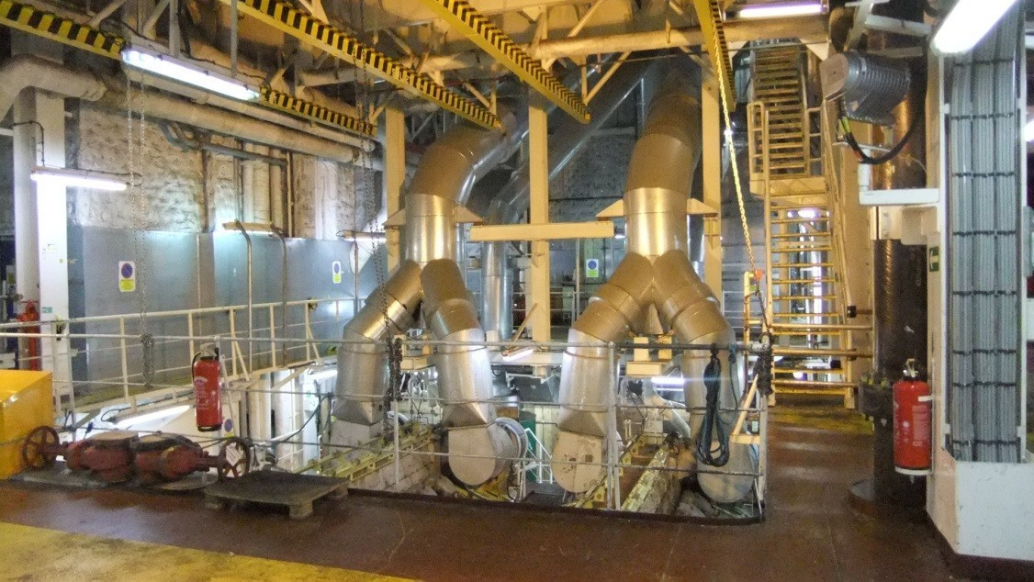
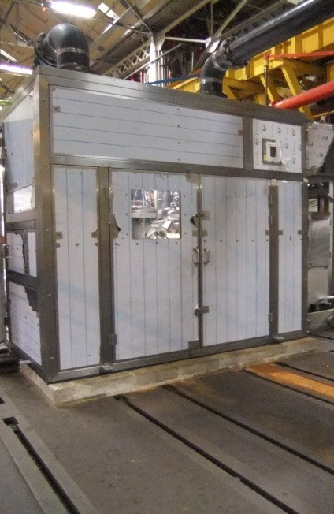

Tagline: Bureau Veritas help identifying technical control measures to reduce personnel noise exposure to As Low As Reasonably Practicable (ALARP).
Link Text: Targeted noise control studies to achieve noise exposure reduction.

A legislative requirement of the Control of Noise at Work Regulations (CoNAWR) is that wherever possible, noise should be eliminated or if not possible, reduced to As Low As Reasonable Practicable (ALARP). This should be achieved by engineering means first before personal protective equipment such as ear plugs and hearing defenders are considered.
By its very wording ALARP means that the cost effectiveness of any noise control measure should be assessed carefully and deemed whether its benefits are worthy of its costs.
Bureau Veritas is capable of carrying out noise control assessments to identify areas and/or machinery that significantly contribute to personnel’s noise exposure and therefore could benefit from the introduction of such measures.
If a NEMS (Noise Exposure Management System) model is being utilised, various simulations can be carried out to evaluate the overall impact of realistically reducing noise levels taking into account the exposure of the employees and the overall effect on the asset. Areas noise levels can be compared with the HSE benchmarking tool that collects information on recorded noise levels per area. Areas found to be falling above the industry average will be highlighted and some outline measures to reduce the noise levels will be given.
Such information will actually allow operators and employers to target specific areas with noise control techniques as the results will show the real changes in the asset’s and personnel’s noise exposure.
Operators will then be able to assess whether the noise control methods are worthy of the costs which will assist with meeting ALARP.

Why Choose Bureau Veritas?
The Acoustics and Vibration team a specialist division of Bureau Veritas and has been supplying noise and vibration management services to the Oil & Gas sector across both UKCS waters and worldwide.
We pride ourselves in our customer focus and can provide a cost-effective solution to help you meet your regulatory requirements. While delivering services that keep up the tradition of impartiality that has made Bureau Veritas a world leader, we aim to help and assist our clients to achieve best practice and reduce downtime and/or safety issues.

